EXPERIMENT 15 — DCL COMMANDS: GRANT, REVOKE

Aim: To learn how to use various DCL commands such as GRANT and REVOKE.”

Create a test user
We will create a user called juiceuser.
Run:
DROP USER IF EXISTS 'juiceuser'@'localhost';

CREATE USER 'juiceuser'@'localhost'
IDENTIFIED BY 'Juice@123';

GRANT SELECT privilege
Now give the user permission to view data from your database.
GRANT SELECT
ON juiceshopff.*
TO 'juiceuser'@'localhost';
Meaning
GRANT → give permission
SELECT → allow viewing data
juiceshopff.* → all tables in juiceshopff

Check the GRANT
Run:
SHOW GRANTS FOR 'juiceuser'@'localhost';
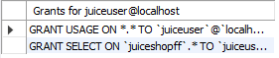

Grant INSERT privilege
Now give the same user permission to insert records.
GRANT INSERT
ON juiceshopff.*
TO 'juiceuser'@'localhost';

Check both privileges
Run:
SHOW GRANTS FOR 'juiceuser'@'localhost';

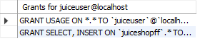

Test INSERT
Still using juiceuser, run:
INSERT INTO juiceshopc
(customer_name, token_no, juice_name, payment_mode, shop_location, no_of_juices)
VALUES
('TestUser', 400, 'Apple', 'Cash', 'Test Street', 1);
It should be allowed because the user has INSERT privilege.
Check:
SELECT * FROM juiceshopc
WHERE token_no = 400;

Go back to your administrator account
Now return to your normal MySQL administrator/root connection.
This is necessary because we are going to REVOKE a privilege from juiceuser.

REVOKE INSERT privilege
Run:
REVOKE INSERT
ON juiceshopff.*
FROM 'juiceuser'@'localhost';
REVOKE removes a previously granted privilege.

STEP 12 — Check the privileges
Run:
SHOW GRANTS FOR 'juiceuser'@'localhost';
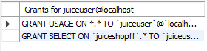

Test SELECT again
Log in as juiceuser and run:
USE juiceshopff;

SELECT * FROM juiceshopc;
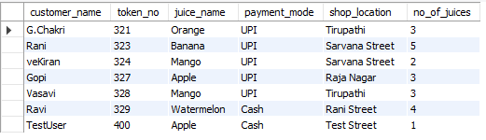

Test INSERT after REVOKE
Now try:
INSERT INTO juiceshopc
(customer_name, token_no, juice_name, payment_mode, shop_location, no_of_juices)
VALUES
('TestUser2', 401, 'Mango', 'UPI', 'Test Street', 2);

Delete the test record
Return to your administrator account and remove the test record that was inserted before the revoke.

DELETE FROM juiceshopc
WHERE token_no = 400;

Then verify:
SELECT * FROM juiceshopc
WHERE token_no = 400;
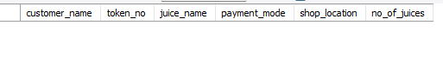
Remove the test user
After finishing the experiment, clean up the temporary user:
DROP USER IF EXISTS 'juiceuser'@'localhost';

RESULT
Thus the DCL commands GRANT and REVOKE were successfully executed and verified.

